**EXPERIMENT NO.2**

**Title of experiment:**To study combinational and sequencial circuits

**Equipments required**: Proteus 8

**Implementation**

1)The AND gate(4081),OR gate(4071),NOR(74S02),XOR(4030),

NOT gate,NAND(4011) are library devices used show the

working of the data in Proteus 8 software.

2)Logicstate,logicprobe devices are used to fetch output

of logic gates.

3)combinational circuits are determined solely by inputs

4)output determined by inputs and previous outputs

**Snapshots**

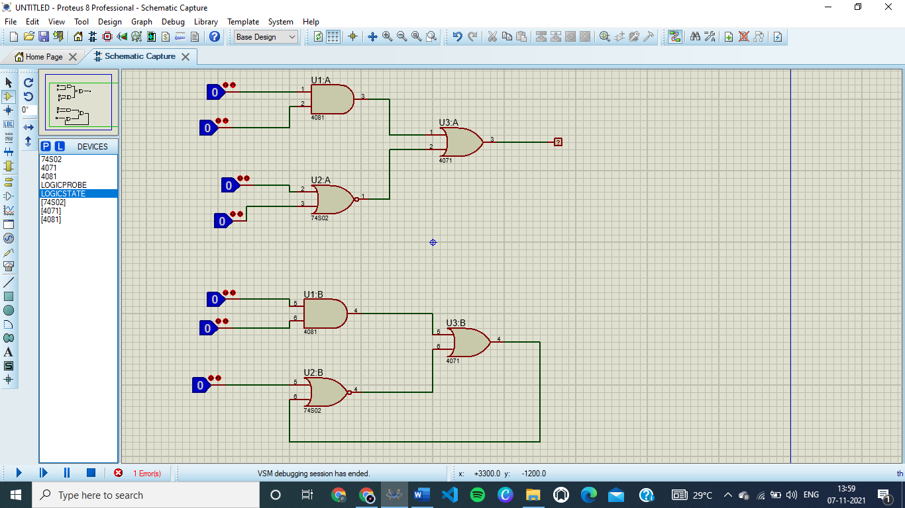

**Conclusion**

The sequential’s outputs are determined by inputs and previous inputs as atleast one output is now available as input and combinational’s outputs are dependent on inputs